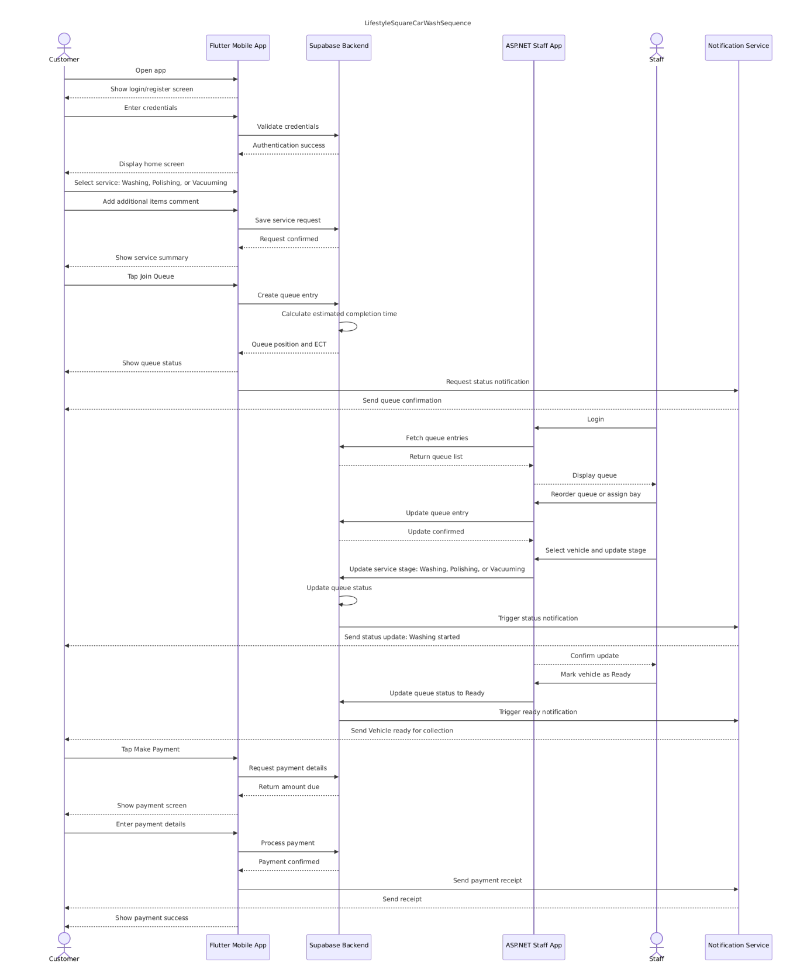
The Sequence Diagram illustrates the dynamic interactions between the Customer, Staff, and the system components of the Lifestyle Square Car Wash Management System. It shows the chronological flow of messages exchanged between actors and objects to complete the main use cases: Registration/Login, Request Service, Join Queue, Manage Queue, Update Status, and Make a Payment.

The diagram focuses on the time-ordered sequence of events that occur when a customer requests a car wash service and staff manage the vehicle through the operational workflow.

Participants (Lifelines)

The following participants are involved in the sequence diagram:

  - Participant Role
- Customer
The end-user who registers, requests services, joins the queue, and makes payments.
- Flutter Mobile App
The customer-facing application used for registration, service requests, queue joining, and payments.
- Supabase Backend
The central database and logic layer that stores all data and calculates estimated completion times.
- ASP.NET web
The staff-facing web application for managing the queue and updating vehicle status.
- Staff Car wash
employees who manage operations and update vehicle progress.
- Notification Service
Sends SMS/WhatsApp updates to customers about queue status, service progress, and payment receipts.

Step-by-Step Description of Interactions

- Customer Authentication (Registration / Login)
The sequence begins when the Customer opens the Flutter Mobile App. The app presents a login or registration screen. The customer enters their credentials, which are sent to the Supabase Backend for validation. On successful authentication, Supabase returns a confirmation to the mobile app, and the customer is taken to the home screen.

- Request Service
The customer selects the type of wash they want: Washing, Polishing, or Vacuuming. They can also provide additional instructions via the Additional Items Comment feature (e.g., “please pay extra attention to the back seat”). The mobile app saves this service request to Supabase, which confirms the request and displays a summary to the customer.

- Join Queue
The customer taps “Join Queue” in the mobile app. This creates a Queue Entry in the Supabase Backend. Supabase then calculates the Estimated Completion Time (ECT) based on the current workload, bay availability, and staff capacity. The queue position and ECT are returned to the mobile app and displayed to the customer. A notification service also sends a confirmation to the customer.

- Staff Manages Queue

A Staff member logs into the ASP.NET Staff App. The app fetches the current queue entries from Supabase and displays them to the staff. Staff can then reorder the queue or assign a wash bay to a vehicle. These updates are saved back to Supabase, ensuring the queue state remains accurate and live.

- Staff Updates Status
As work progresses, staff select a vehicle and update its service stage (e.g., Washing → Polishing → Vacuuming). The ASP.NET app sends this update to Supabase, which updates the queue status accordingly. Supabase then triggers a notification through the Notification Service, which sends a status update to the customer (e.g., “Your vehicle is now being washed”). The staff app confirms the update to the staff member.

- Vehicle Ready
When the vehicle is finished, staff mark it as “Ready” in the ASP.NET app. Supabase updates the queue status to Ready and triggers the Notification Service to send a “Vehicle ready for collection” message to the customer.

- Make Payment
The customer taps “Make Payment” in the mobile app. The app requests the amount due from Supabase. The customer enters their payment details, and the mobile app sends the payment request to Supabase for processing. Once payment is confirmed, Supabase returns a confirmation to the mobile app. A payment receipt is sent to the customer via the Notification Service, and the mobile app displays a payment success message.

